Paired t-tests for pre & post exclusion task of money spent on social experiences

| **Paired Samples T-Test** | | | | | | | | | | | | | | | | | | | | | |
| --- | --- | --- | --- | --- | --- | --- | --- | --- | --- | --- | --- | --- | --- | --- | --- | --- | --- | --- | --- | --- | --- |
|  | | | | | | | | | | | | | | | | **95% Confidence Interval** | | | |  | |
|  | |  | |  | | **statistic** | | **df** | | **p** | | **Mean difference** | | **SE difference** | | **Lower** | | **Upper** | | **Cohen's d** | |
| $Pre Social |  | $PostSocial |  | Student's t |  | 1.67 |  | 16.0 |  | 0.114 |  | 0.102 |  | 0.0609 |  | -0.0274 |  | 0.231 |  | 0.405 |  |
|  | | | | | | | | | | | | | | | | | | | | | |

| **Test of Normality (Shapiro-Wilk)** | | | | | | | | | | | | | | | | | | | | | |
| --- | --- | --- | --- | --- | --- | --- | --- | --- | --- | --- | --- | --- | --- | --- | --- | --- | --- | --- | --- | --- | --- |
|  | | |  | |  | |  |  | | | | |  |  | | |  |  | | |  |
|  | | | | |  | | |  | | | | | | **W** | | | | **p** | | | |
| $Pre Social | | |  | | - | |  | $PostSocial | | | | |  | 0.715 | | |  | < .001 | | |  |
| Note. A low p-value suggests a violation of the assumption of normality | | | | | | | | | | | | | | | | | | | | | |
|  | | | | | | | | | | | | | | | | | | | | | |
| **Descriptives** | | | | | | | | | | | | | | | | | | | |
|  |  |  | |  | |  | | |  |  |  |  | | |  |  | | |  |
|  | | **N** | | | | **Mean** | | | | **Median** | | **SD** | | | | **SE** | | | |
| $Pre Social |  | 17 | |  | | 1.52 | | |  | 1.59 |  | 0.307 | | |  | 0.0745 | | |  |
| $PostSocial |  | 17 | |  | | 1.41 | | |  | 1.60 |  | 0.426 | | |  | 0.1033 | | |  |
|  | | | | | | | | | | | | | | | | | | | |

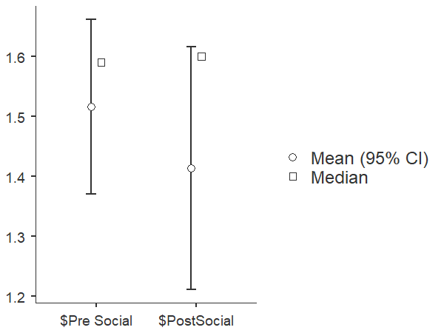

Paired t-tests for pre & post exclusion task of money spent on non-social experiences

| **Paired Samples T-Test** | | | | | | | | | | | | | | | | | | | | | |
| --- | --- | --- | --- | --- | --- | --- | --- | --- | --- | --- | --- | --- | --- | --- | --- | --- | --- | --- | --- | --- | --- |
|  | | | | | | | | | | | | | | | | **95% Confidence Interval** | | | |  | |
|  | |  | |  | | **statistic** | | **df** | | **p** | | **Mean difference** | | **SE difference** | | **Lower** | | **Upper** | | **Cohen's d** | |
| $Pre Nonsocial |  | $Post Nonsocial |  | Student's t |  | -0.157 |  | 16.0 |  | 0.877 |  | -0.00235 |  | 0.0149 |  | -0.0340 |  | 0.0293 |  | -0.0382 |  |
|  | | | | | | | | | | | | | | | | | | | | | |

| **Test of Normality (Shapiro-Wilk)** | | | | | | | | | |
| --- | --- | --- | --- | --- | --- | --- | --- | --- | --- |
|  |  |  |  |  |  |  |  |  |  |
|  | |  | |  | | **W** | | **p** | |
| $Pre Nonsocial |  | - |  | $Post Nonsocial |  | 0.972 |  | 0.845 |  |
| Note. A low p-value suggests a violation of the assumption of normality | | | | | | | | | |
|  | | | | | | | | | |

| **Descriptives** | | | | | | | | | | | |
| --- | --- | --- | --- | --- | --- | --- | --- | --- | --- | --- | --- |
|  |  |  |  |  |  |  |  |  |  |  |  |
|  | | **N** | | **Mean** | | **Median** | | **SD** | | **SE** | |
| $Pre Nonsocial |  | 17 |  | 0.378 |  | 0.380 |  | 0.170 |  | 0.0412 |  |
| $Post Nonsocial |  | 17 |  | 0.380 |  | 0.400 |  | 0.192 |  | 0.0465 |  |
|  | | | | | | | | | | | |

